SPRINT DELIVERY 3

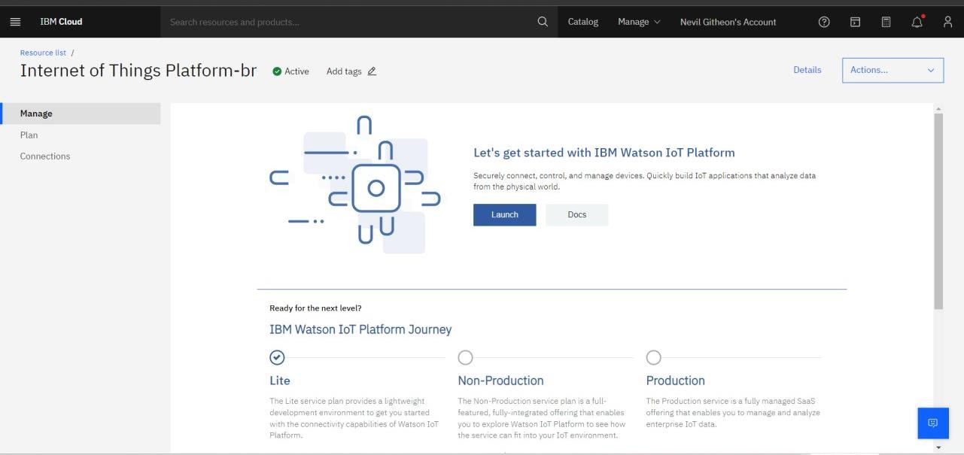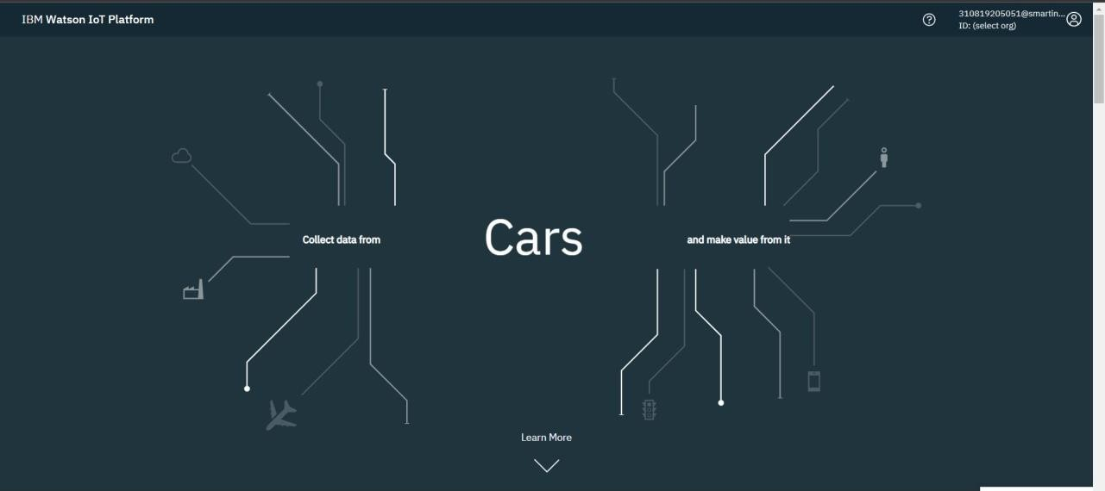

TEAM ID: PNT2022TMID19437

PROJECT NAME: PERSONAL ASSISTANCE FOR SENIORS WHO ARE SELF RELIANT

IBM IOT WATSON DEVICE CREATION

